Project 2: ABAQUS Static Structural: Effect of multiple loads on a beam

Problem Statement: Evaluate the static structural performance of a beam with pressure and concentrated force loading.

Geometry:
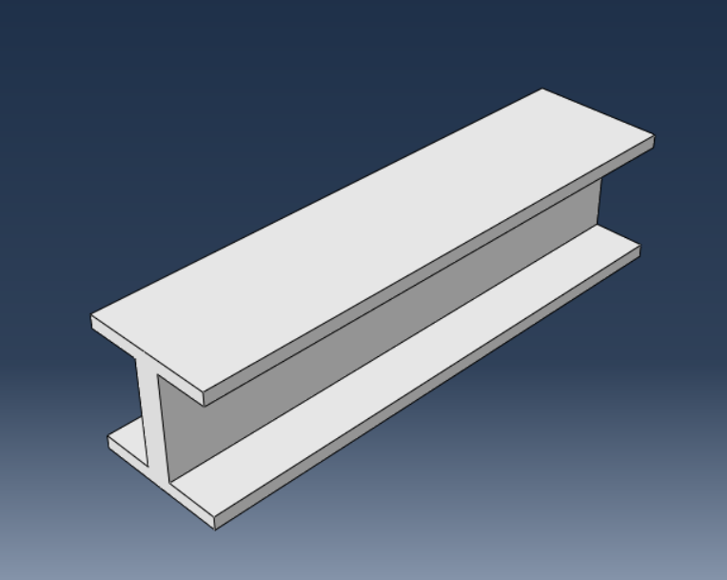

Material Properties:
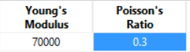

Loading:
- Right surface is fixed.
- Pressure on top surface,
- Concentrated force on the side.

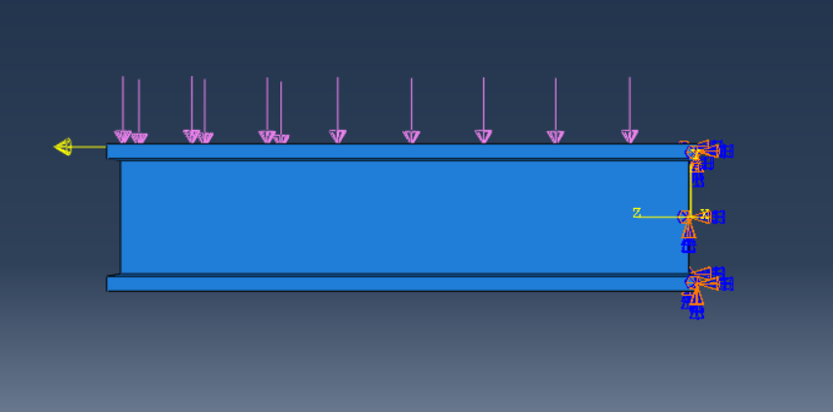
Mesh: (coarse due to limitation of 1000 nodes in ABAQUS educational version).

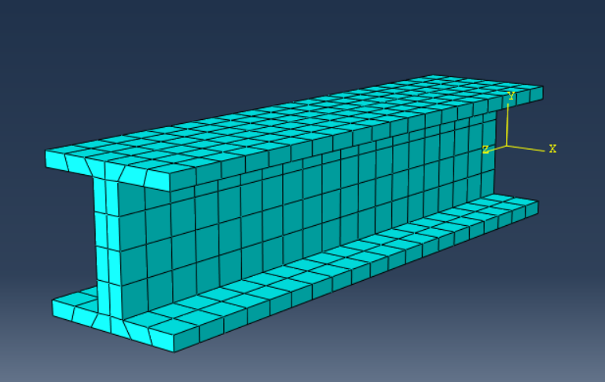

Results:
Deformation:
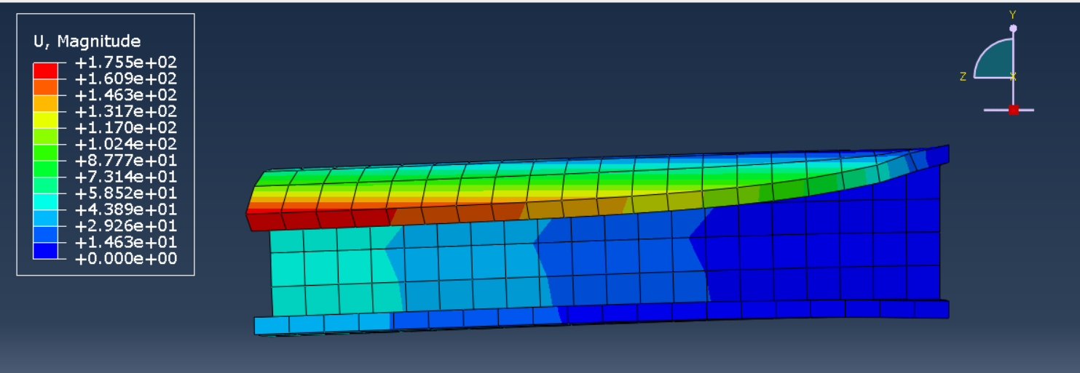

Von Mises Stress:
